USA MASS SHOOTING ANALISATION FOR PEACE

**Technical Architecture:**

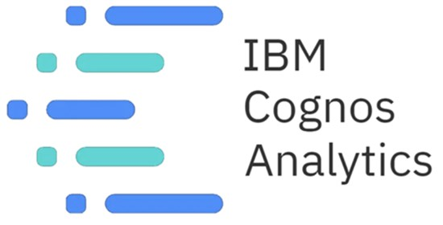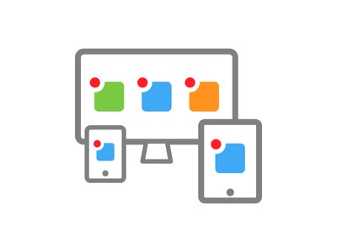

**Project Flow**

To accomplish this, we have to complete all the activities listed below,

Define Problem / Problem Understanding

o Specify the business problem o Business requirements o Literature Survey o Social or Business Impact.

* Data Collection & Extraction from Database o Collect the dataset, o Connect IBM DB2 with IBM cognos
* Data Preparation o Prepare the Data for Visualization
* Data Visualizations o No of Unique Visualizations
* Dashboard
  + Responsive and Design of Dashboard
* Story
  + No of Scenes of Story
* Report
  + Creating a report
* Performance Testing o Amount of Data Rendered to DB ‘ o Utilization of Data Filters o No of Calculation Fields o No of Visualizations/ Graphs
* Web Integration o Dashboard and Story embed with UI With Flask
* Project Demonstration & Documentation o Record explanation Video for project end to end solution o Project Documentation-Step by step project development procedure

# Milestone 1: Define Problem / Problem Understanding

**Activity 1: Specify the business problem**

Refer Project Description

## Activity 2: Business requirements

The business requirements for this project would likely include

## Activity 3: Literature Survey (Student Will Write)

**Activity 4: Social or Business Impact.**

**Social Impact:**

**Business Model/Impact**:

# Milestone 2: Data Collection & Extraction from Database

Data collection is the process of gathering and measuring information on variables of interest, in an established systematic fashion that enables one to answer stated research questions, test hypotheses, and evaluate outcomes and generate insights from the data.

**Activity 1: Collect the dataset** Please use the link to download the dataset:

[**https://data.world/markbradbourne/rwfd-real-world-fake-data/workspace/file?filename=SocialM edia.csv**](https://data.world/markbradbourne/rwfd-real-world-fake-data/workspace/file?filename=SocialMedia.csv)

## Activity 1.1: Understand the data

Check the below link out to understand the dataset in detail:

[**https://data.world/markbradbourne/rwfd-real-world-fake-data/workspace/file?filename=SocialM edia.csv**](https://data.world/markbradbourne/rwfd-real-world-fake-data/workspace/file?filename=SocialMedia.csv)

## Activity 2: Connect IBM DB2 with IBM Cognos

Explanation video link:

[**https://drive.google.com/file/d/15-vCoLX9zRQGV7vAg1brD--XjNjaZm8g/view?usp=share_link**](https://drive.google.com/file/d/15-vCoLX9zRQGV7vAg1brD--XjNjaZm8g/view?usp=share_link)

# Milestone 3: Data Preparation

## Activity 1: Prepare the Data for Visualization

Preparing the data for visualization involves cleaning the data to remove irrelevant or

missing data, transforming the data into a format that can be easily visualized, exploring the data to identify patterns and trends, filtering the data to focus on specific subsets of data, preparing the data for visualization software, and ensuring the data is accurate and complete. This process helps to make the data easily understandable and ready for creating visualizations to gain insights into the performance and efficiency.

● **Activity 1.1** : **Preparing a Data Module**:

[**https://drive.google.com/file/d/19GOdZ3eJJL2D6h4kv9DuTp35J-_LyvdL/view ?usp=share_link**](https://drive.google.com/file/d/19GOdZ3eJJL2D6h4kv9DuTp35J-_LyvdL/view?usp=share_link)

# Milestone 4: Data Visualization

Data visualization is the process of creating graphical representations of data in order to help people understand and explore the information. The goal of data visualization is to make complex data sets more accessible, intuitive, and easier to interpret. By using visual elements such as charts, graphs, and maps, data visualizations can help people quickly identify patterns, trends, and outliers in the data.

## Activity 1: No of Unique Visualizations

The number of unique visualizations that can be created with a given dataset. Some common types of visualizations that can be used to analyse the Twitter data include bar charts, line charts, heat maps, scatter plots, pie charts,Maps etc. These visualizations can be used to compare performance, track changes over time, show distribution, and relationships between variables.

**Activity 1.1: No.of URL clicks by month**

**Explanation video link:**

[**https://drive.google.com/file/d/10agQsB0KIhwvznzOJ5RBBqZ0vUq_k2Rg/view? usp=share_link**](https://drive.google.com/file/d/10agQsB0KIhwvznzOJ5RBBqZ0vUq_k2Rg/view?usp=share_link)

**Activity 1.2: Data of media view, media engagements**

**Explanation video link:**

[**https://drive.google.com/file/d/14vTYBcg45SfMD-ciC4eZv67qARAR-Yls/view?us p=share_link**](https://drive.google.com/file/d/14vTYBcg45SfMD-ciC4eZv67qARAR-Yls/view?usp=share_link)

**Activity 1.3: No.of impressions by month**

**Explanation video link:**

[**https://drive.google.com/file/d/1tDE4sVOA-MbXZogZL2sUZ25fs1F75OMn/view? usp=share_link**](https://drive.google.com/file/d/1tDE4sVOA-MbXZogZL2sUZ25fs1F75OMn/view?usp=share_link)

**Activity 1.4: Impressions by retweets**

**Explanation video link:**

[**https://drive.google.com/file/d/1agyLWOuRDHzKzcmEna067UjFrM0ANzL7/view ?usp=share_link**](https://drive.google.com/file/d/1agyLWOuRDHzKzcmEna067UjFrM0ANzL7/view?usp=share_link)

**Activity 1.5: Engagements by retweet in year**

**Explanation video link:**

[**https://drive.google.com/file/d/11rgfe4zBZLuvPbjT2mYDqchXcIsEz_pp/view?us p=share_link**](https://drive.google.com/file/d/11rgfe4zBZLuvPbjT2mYDqchXcIsEz_pp/view?usp=share_link)

**Activity 1.6: Describe detailed expands through hashtag clicks**

**Explanation video link:**

[**https://drive.google.com/file/d/1y_VQzRtPj47yLMqwH22HN6GA38uc3Htc/view? usp=share_link**](https://drive.google.com/file/d/1y_VQzRtPj47yLMqwH22HN6GA38uc3Htc/view?usp=share_link)

**Activity 1.7: Data of email tweets,retweets and likes**

**Explanation video link:**

[**https://drive.google.com/file/d/1_67xQs_Gp9TaxDi6USi8WTXHAY7ASlq2/view?u sp=share_link**](https://drive.google.com/file/d/1_67xQs_Gp9TaxDi6USi8WTXHAY7ASlq2/view?usp=share_link)

**Activity 1.8: No.of retweets**

**Explanation video link:**

[**https://drive.google.com/file/d/1daj9ArOh5pJo3SY2d4OK6SUIrASIaC19/view?usp =share_link**](https://drive.google.com/file/d/1daj9ArOh5pJo3SY2d4OK6SUIrASIaC19/view?usp=share_link)

# Milestone 5: Dashboard

A dashboard is a graphical user interface (GUI) that displays information and data in an organized, easy-to-read format. Dashboards are often used to provide real-time monitoring and analysis of data, and are typically designed for a specific purpose or use case. Dashboards can be used in a variety of settings, such as business, finance, manufacturing, healthcare, and many other industries. They can be used to track key performance indicators (KPIs), monitor performance metrics, and display data in the form of charts, graphs, and tables.

## Activity :1- Responsive and Design of Dashboard

The responsiveness and design of a dashboard for analysing the factors important for Dissecting the Digital Landscape: A Comprehensive Analysis of Social Media analyzes various engagement metrics such as likes, comments, shares, and retweets to understand the level of engagement on different social media platforms.It analyzes social media trends and patterns to understand the changing preferences and interests of users.

Explanation video link:

[**https://drive.google.com/file/d/1xk7hnYrPxn_7vSoWlJpqf55ptXO_URfu/view?us p=share_link**](https://drive.google.com/file/d/1xk7hnYrPxn_7vSoWlJpqf55ptXO_URfu/view?usp=share_link)

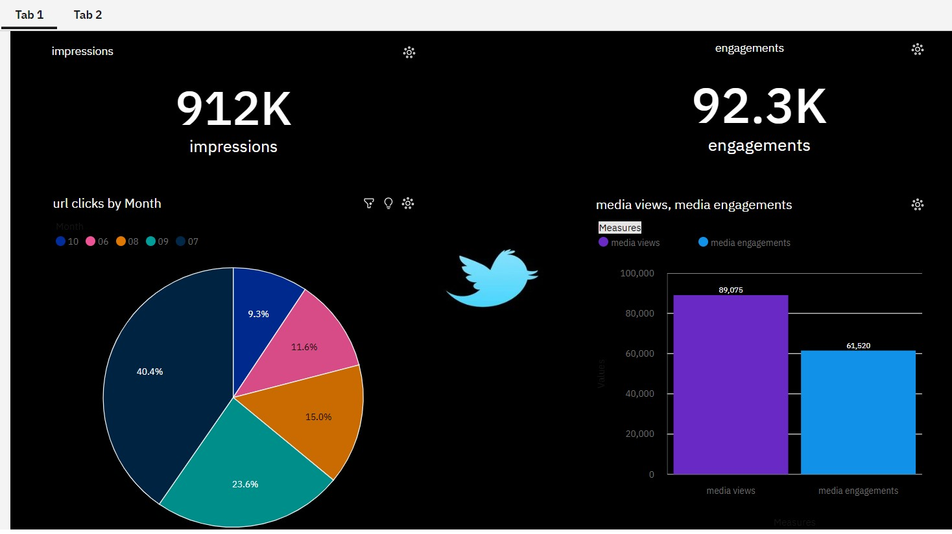

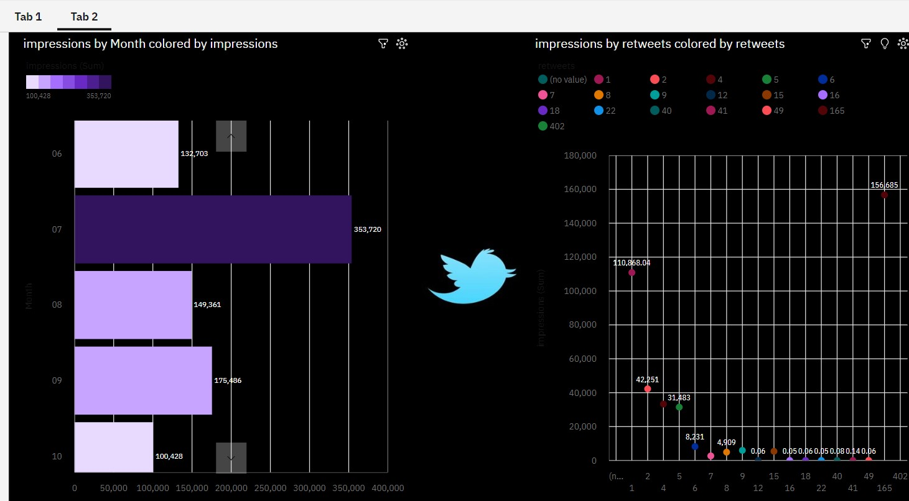

**Milestone 6: Story**

A data story is a way of presenting data and analysis in a narrative format, with the goal of making the information more engaging and easier to understand. A data story typically includes a clear introduction that sets the stage and explains the context for the data, a body that presents the data and analysis in a logical and systematic way, and a conclusion that summarizes the key findings and highlights their implications. Data stories can be told using a variety of mediums, such as reports, presentations, interactive visualizations, and videos.

## Activity:1- No of Scenes of Story

The number of scenes in a storyboard for a data visualization analysis of the factors affecting the insights of twitter , will depend on the complexity of the analysis and the specific insights that are trying to be conveyed. A storyboard is a visual representation of the data analysis process and it breaks down the analysis into a series of steps or scenes.

**Explanation video link:**

[**https://drive.google.com/file/d/1rC3Y9Rd5IH2HgDxJYeXWRkcimob2JS_k/view?**](https://drive.google.com/file/d/1rC3Y9Rd5IH2HgDxJYeXWRkcimob2JS_k/view?usp=share_link)

[**usp=share_link**](https://drive.google.com/file/d/1rC3Y9Rd5IH2HgDxJYeXWRkcimob2JS_k/view?usp=share_link)

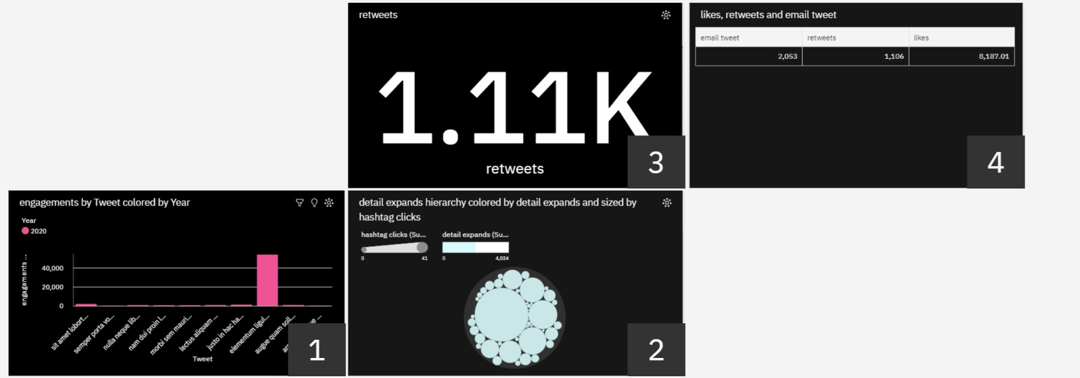

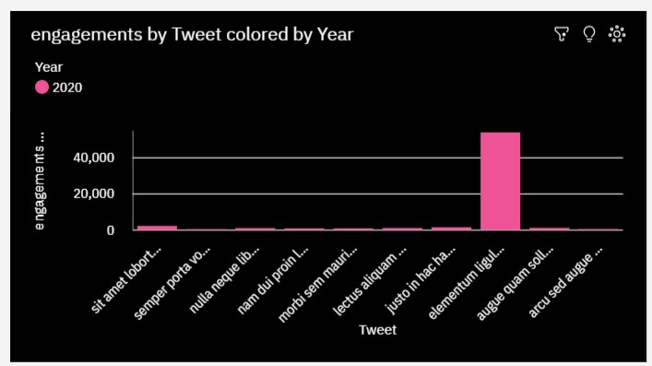

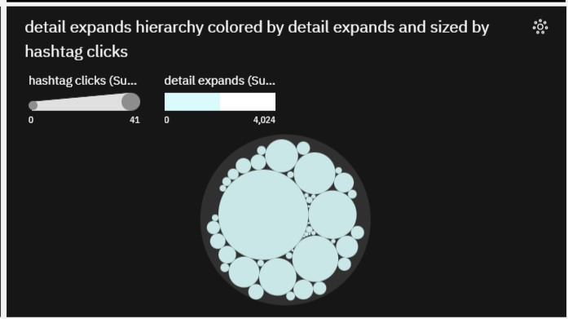

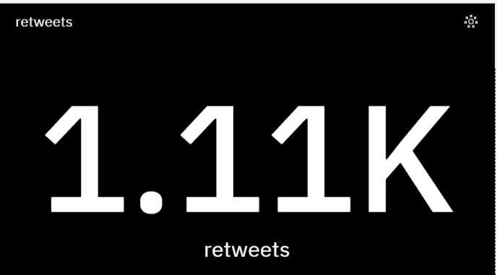

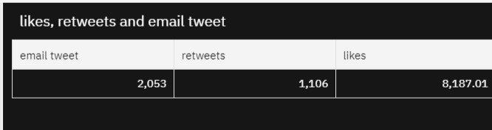

# Milestone 7: Report

A report is a document that presents information in a specific format and layout, usually based on data from a database or other data source. A report in IBM Cognos can contain various elements, such as tables, charts, graphs, and images, as well as text and data elements, and it is designed to be used by business users to help them better understand their data and make informed decisions. There are several different types of reports available in IBM Cognos, including list reports, crosstab reports, chart reports, and report studio reports, among others. The type of report that you choose will depend on the specific needs and requirements of your organization, as well as the data that you need to present.

## Activity 1 : Creating a report

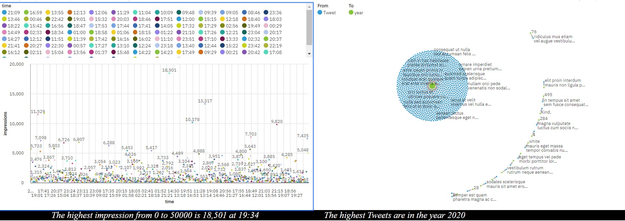

**Explanation video link:**

[**https://drive.google.com/file/d/1pY1zTtHmHsWR_lb4rI-Phg37HziA2tBH/view?usp=share_link**](https://drive.google.com/file/d/1pY1zTtHmHsWR_lb4rI-Phg37HziA2tBH/view?usp=share_link)

# Milestone 8: Performance Testing

**Activity 1: Utilization of Data Filters**

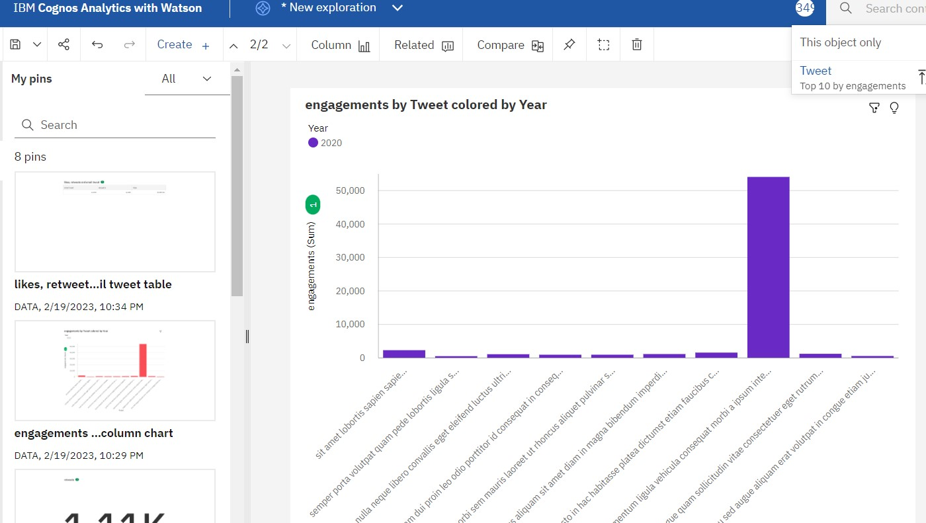

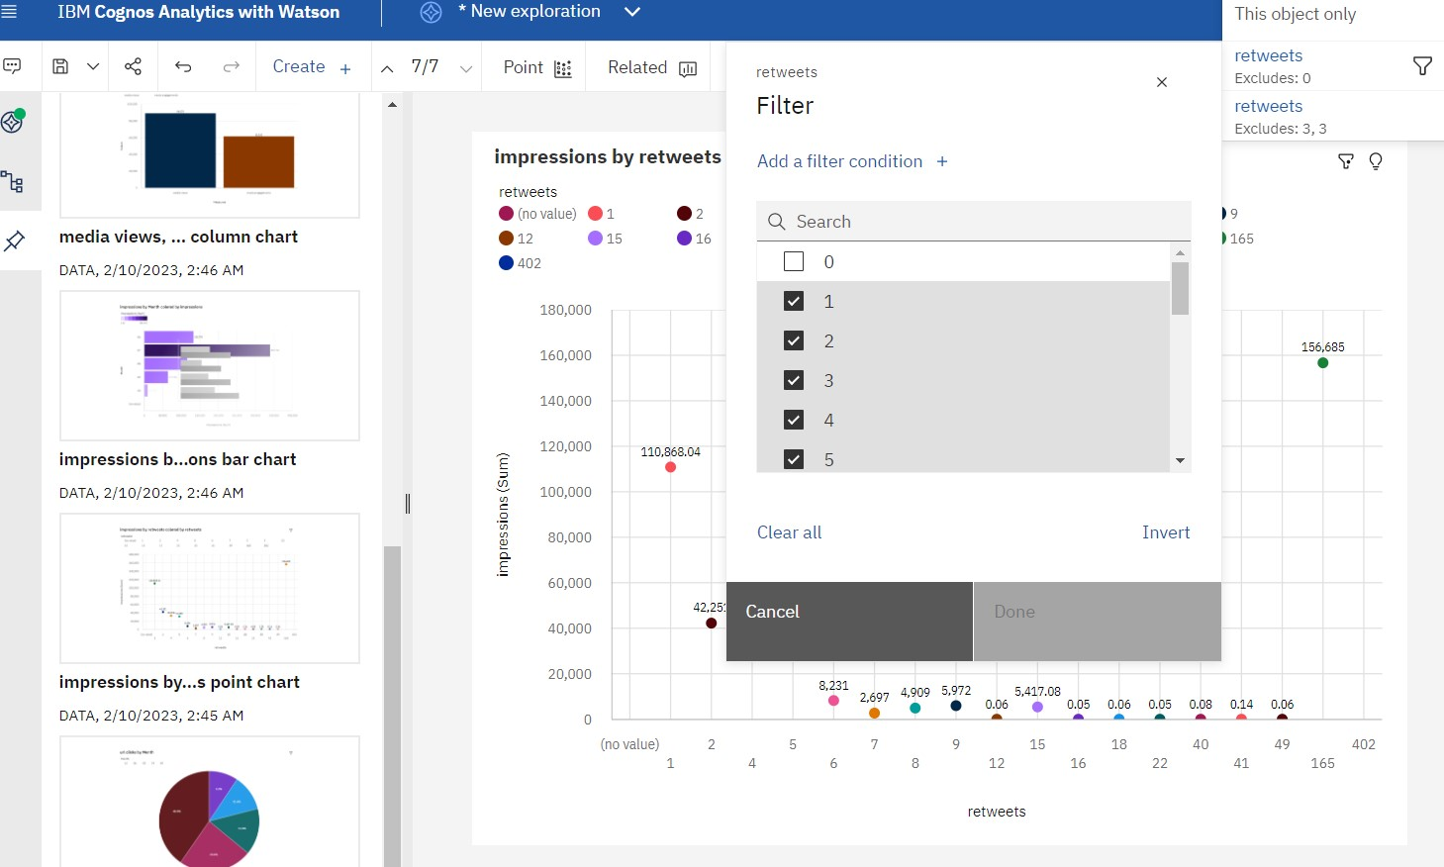

## Activity 3: No of Calculation Fields

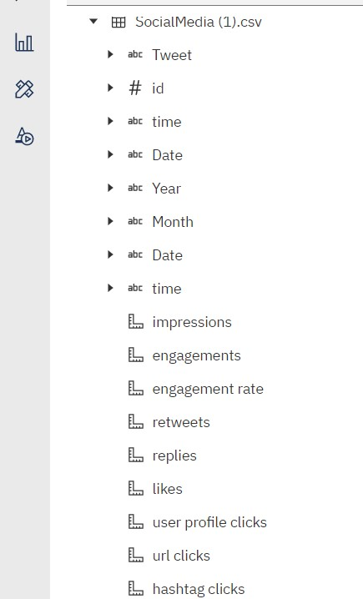

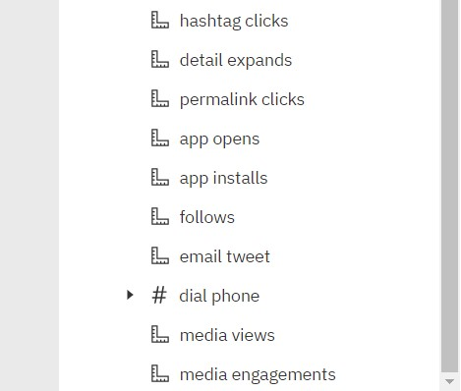

## Activity 4: No of Visualizations/ Graphs

1)No.of URL clicks by month

2)Data of media views , media engagements

3)No.of impressions by month

4)Impressions by retweets

5)Engagements by retweet in year

6)Describe detail expands through hashtag clicks

7)a table of email tweets,retweets and likes

8)No.of retweets

9)Most Tweeted year?

10)Highest impressions based on time

# Milestone 9: Web integration

Publishing helps us to track and monitor key performance metrics, to communicate results and progress. help a publisher stay informed, make better decisions, and communicate their performance to others.

**Integrating dashboard/reports/stories to web**

Step 1: Go to Dashboard/story/report, click on share button on the top ribbon

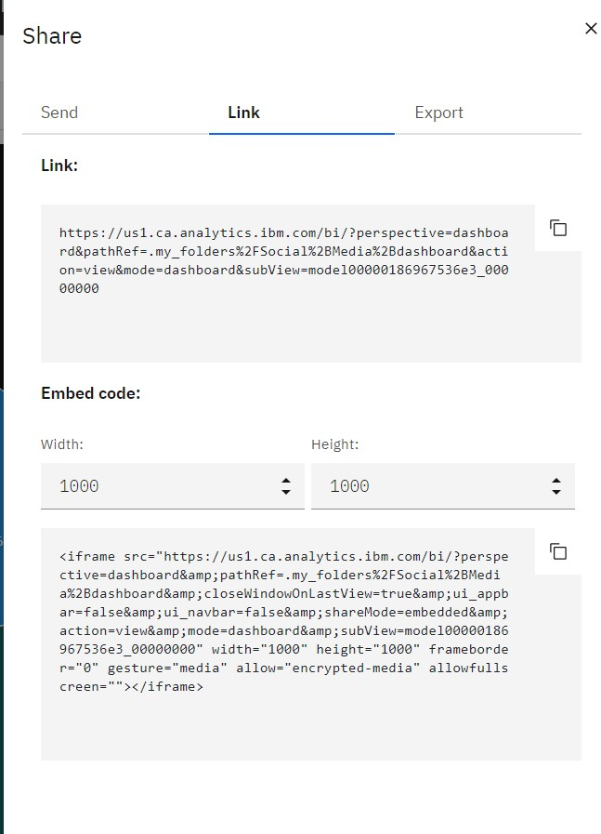

**Note: You can also change the width and height of the dashboard/story/report as you like.**

## Activity 1: Dashboard and Story embed with UI With Flask

**Explanation video link:** [**https://drive.google.com/file/d/1fIcZCYnwSnfp3pN7or1KyGj4tti8rEf_/view? usp=share_link**](https://drive.google.com/file/d/1fIcZCYnwSnfp3pN7or1KyGj4tti8rEf_/view?usp=share_link)

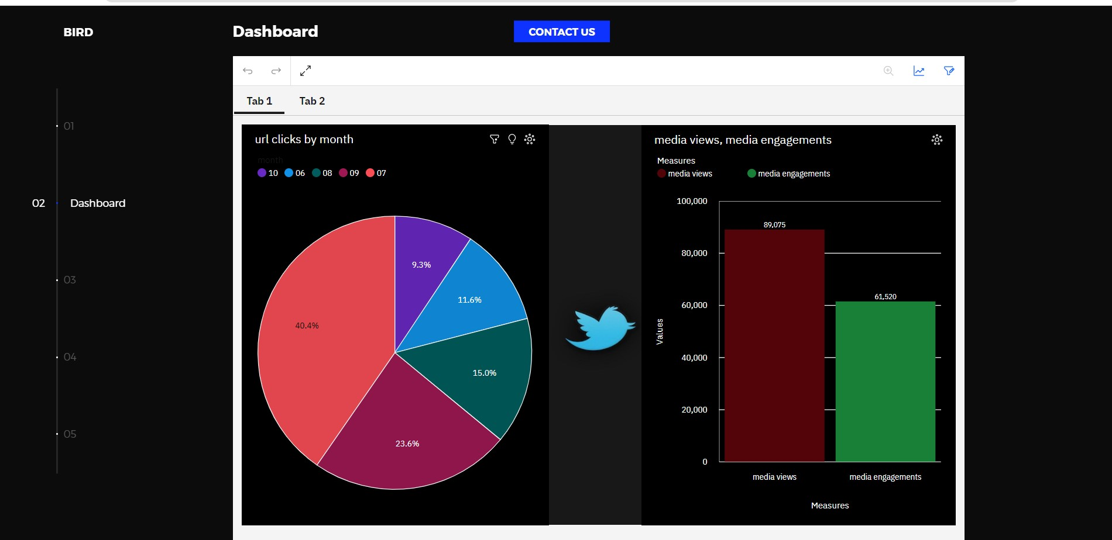

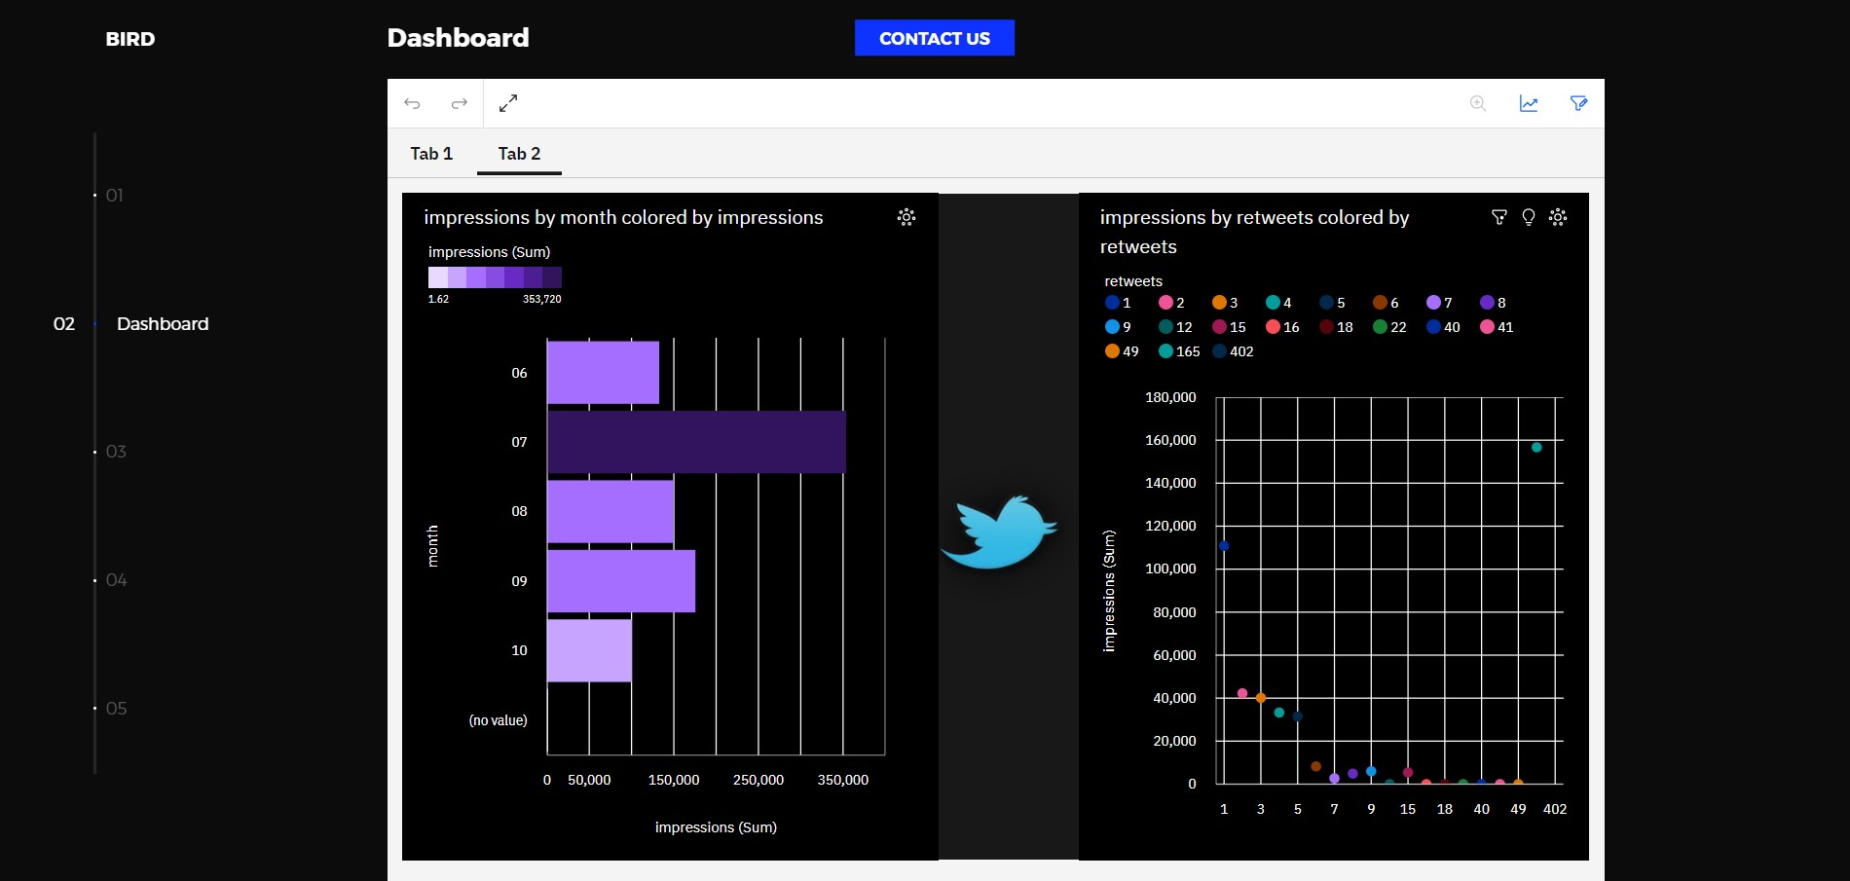

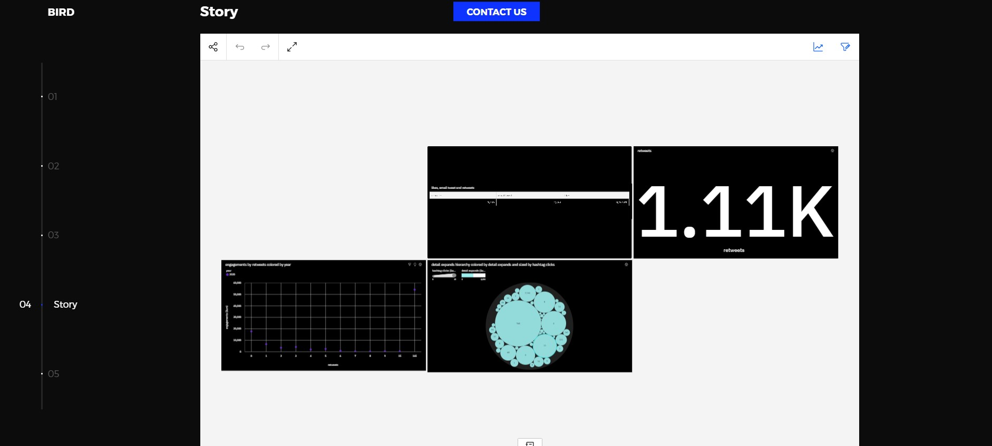

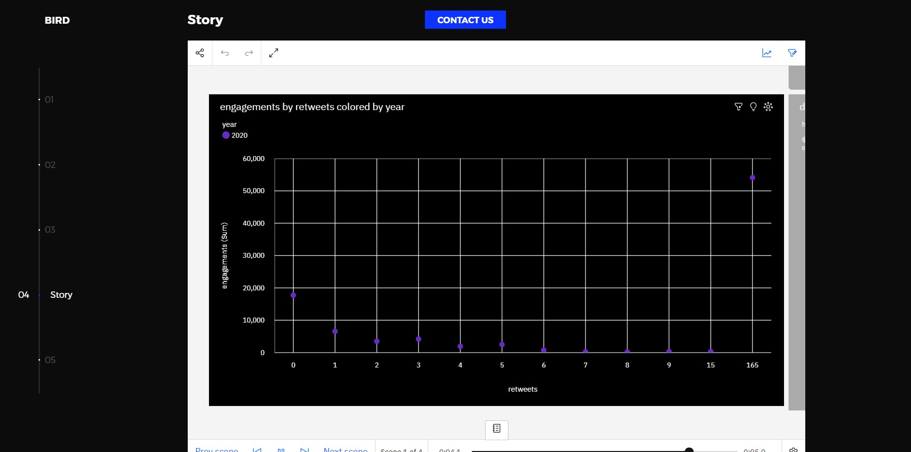

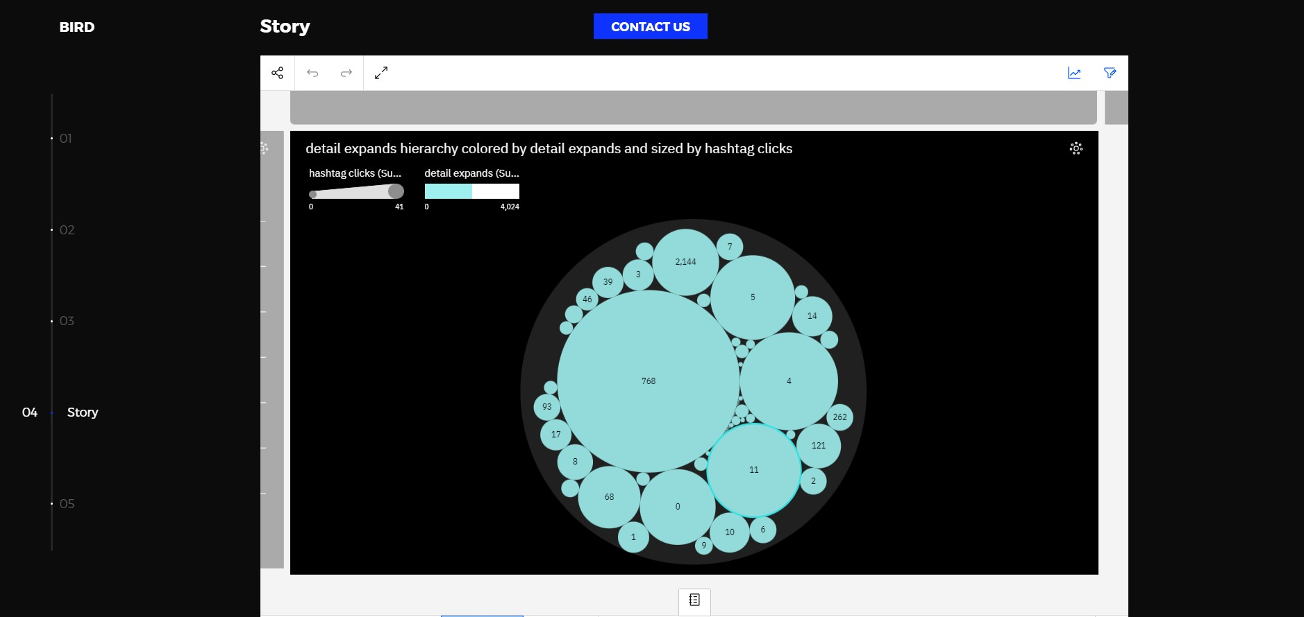

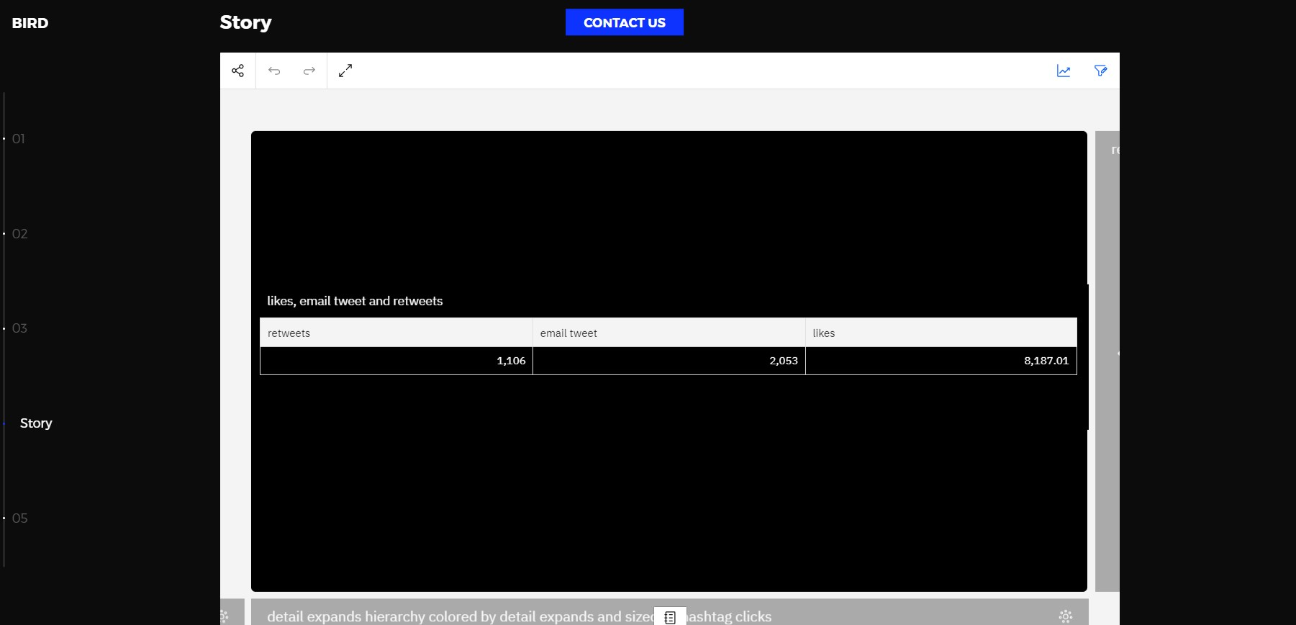

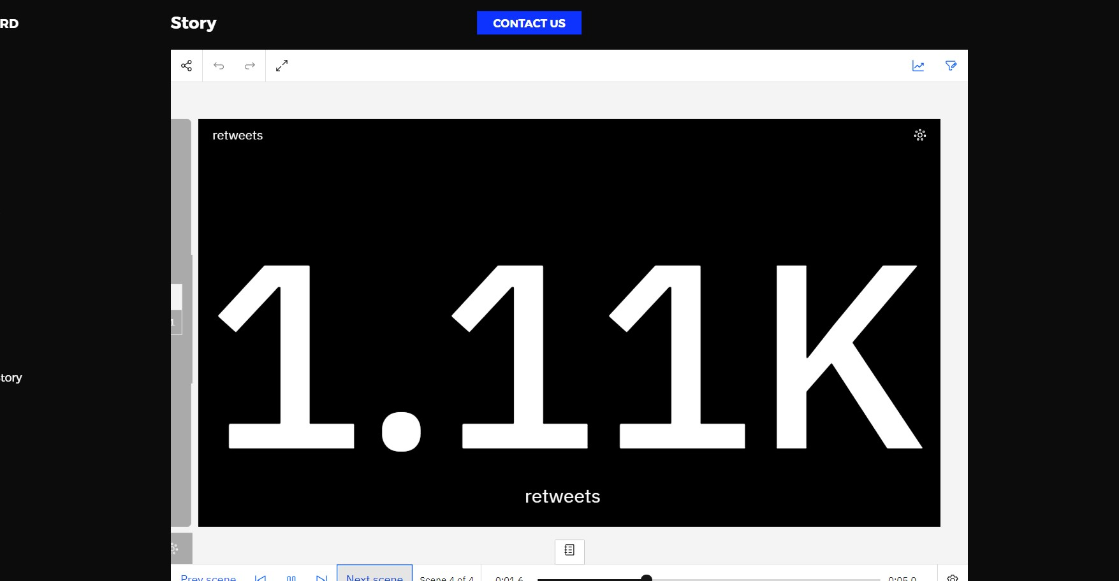

# Milestone 10: Project Demonstration & Documentation

Below mentioned deliverables to be submitted along with other deliverables

**Activity 1:- Record explanation Video for project end to end solution**

## Activity 2:- Project Documentation-Step by step project development procedure

Create document as per the template provided